

Using the NXP Ebill custom tab and ebill format
For each matter using this ebill format the firm will need to do a little setup based on how you want the ebill to populate. Let’s look at each field individually.

Ebill Client ID
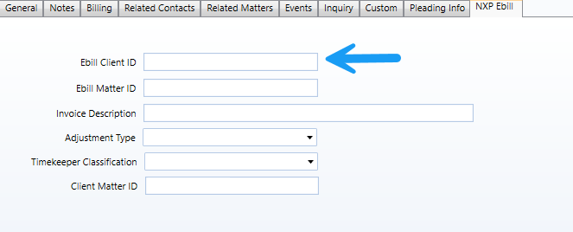
If you want the 3rd column on the ebill named CLIENT_ID to be custom, fill in the Ebill Client ID field on the NXP Ebill custom tab. If that field is blank, the default Client ID will be used.

Ebill Matter ID
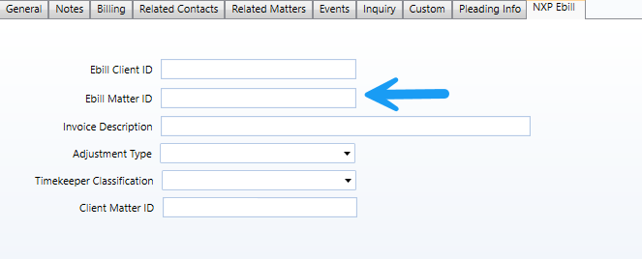
If you want the 4th column on the ebill named LAW_FIRM_MATTER_ID to be custom, fill in the Ebill Matter ID field on the NXP Ebill custom tab. If that field is blank, the default Matter ID will be used.

Invoice Description
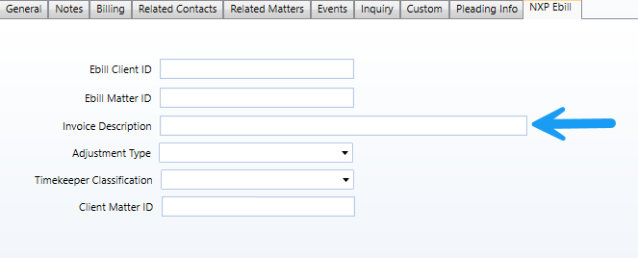
The INVOICE_DESCRIPTION (Column 8) on the ebill will pull from the Invoice Description on the NXP Ebill custom tab. Leave this field blank if the client does not require an invoice description.

Adjustment Type
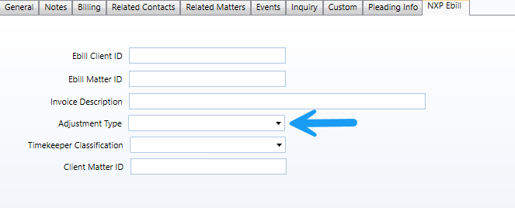
This is a picklist that has 2 options. The 12th column on the ebill named LINE_ITEM_ADJUSTMENT_AMOUNT will populate based on the option you select.
Option 1: Discount This will pull the discount amount as a negative value
Option 2: Ext Amount – Value This will pull the difference between the Ext Amount field and the Value on the transaction. Typically, this is a negative amount if you do a write down.

Timekeeper Classification
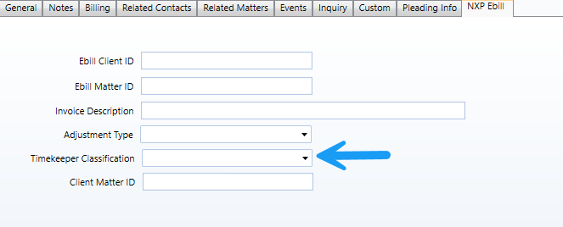
This is a picklist that has 4 options. The 23rd column on the ebill named TIMEKEEPER_CLASSIFICATION will populate based on the option you choose. This does require setup on the field selected.
Option 1: Nickname Fill in the nickname field on the Professional record.
Option 2: Custom Fill in the custom field on the default custom tab in Professionals
Option 3: Prof Class Fill in the Professional Class on the Professional Record
Option 4: Prof Type Fill in the Professional Type on the Professional Record

Client Matter ID
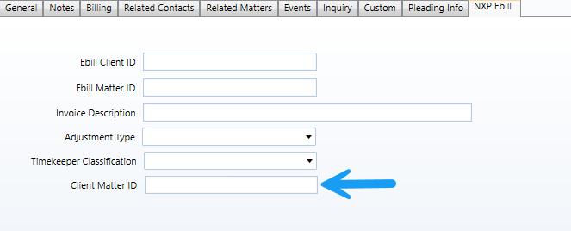
The last field on the ebill named CLIENT_MATTER_ID pulls from this field. This almost always requires a value that is provided to you from your client. If this field is blank, the default Matter ID will be used.

Line Item Activity Code
There is not a custom field for this but the 15th column of the ebill named LINE_ITEM_ACTIVITY_CODE is populated one of two ways. If the activity code field for the transaction is blank, then the ebill will use the component id. Otherwise, the activity code id on the transaction will be used. This is because in earlier versions of ProLaw, firms had to enter their activity codes as Components because there was no Activity Code field available. This ebill takes this into account so even older firms that may not be using the new Activity Code field can have this populate correctly.

